**EUROPEAN UNIVERSITY of LEFKE**

**Faculty of Engineering**

**Department of Electrical and Electronic Engineering EE 342 / ECE 314 – Communication Systems I PROJECT ASSIGNMENT**

|  |  |  |  |  |
| --- | --- | --- | --- | --- |
| Std. No:**20140121** |  | Name: **NOUMAN ALI** | Gr: | Class: _ _ _ _ _ |

# Due to: 02/06/2023, until 17:00 pm.

**Design and implement an AM transmitter and receiver using an LC oscillator and an envelope detector**

1. **Abstract:**

This project aims to design and implement an AM (Amplitude Modulation) transmitter and receiver using an LC oscillator and an envelope detector. The goal is to enable the transmission and reception of analog audio signals over radio frequencies. The transmitter comprises an LC oscillator as the carrier wave generator and an audio input circuit for modulating the carrier wave with the audio signal. On the other hand, the receiver consists of an antenna for capturing the modulated signal, an envelope detector for extracting the audio signal, and an audio output circuit for reproducing the sound.

The LC oscillator serves as the core component of the transmitter, producing a high-frequency carrier wave typically in the AM broadcast band. The audio input circuit modulates the carrier wave by varying its amplitude according to the audio signal, effectively encoding the audio information into the transmitted signal. At the receiver end, the antenna captures the transmitted signal, which is then directed to the envelope detector. The envelope detector employs rectification and filtering techniques to recover the modulated audio signal, effectively separating it from the carrier frequency. Finally, the audio output circuit amplifies and converts the demodulated audio signal into sound waves, making it audible to the listener.

1. **Introduction:**

The transmitter consists of an LC oscillator, which generates the carrier wave, and an audio input circuit that modulates the carrier wave with the desired audio signal. The receiver comprises an antenna to capture the modulated signal, an envelope detector to extract the audio signal, and an audio output circuit to reproduce the sound designing and implementing an AM transmitter and receiver using an LC oscillator and an envelope detector is a practical way to experiment with basic analog modulation and demodulation techniques. It provides insights into the principles of amplitude modulation and allows for the transmission and reception of audio signals wirelessly over a short distance. AM modulation involves varying the amplitude of a carrier wave in accordance with the audio signal to be transmitted, enabling the faithful reproduction of the original audio at the receiving end.

**Define AM modulation:**

Designing and implementing an AM transmitter and receiver using an LC oscillator and an envelope detector refers to the process of creating a system that can transmit and receive amplitude-modulated (AM) signals. The design involves selecting and configuring an LC oscillator circuit to generate a carrier wave within the AM frequency range. The audio signal is then modulated onto this carrier wave by varying its amplitude using an appropriate modulator circuit.

On the receiver side, an antenna captures the transmitted signal, which is then processed by an envelope detector circuit. The envelope detector extracts the modulated audio signal by rectifying and filtering the received signal, separating it from the carrier frequency. The demodulated audio signal is further amplified and converted into sound waves for output. The successful implementation of this system enables the wireless transmission and reception of analog audio signals using AM modulation.

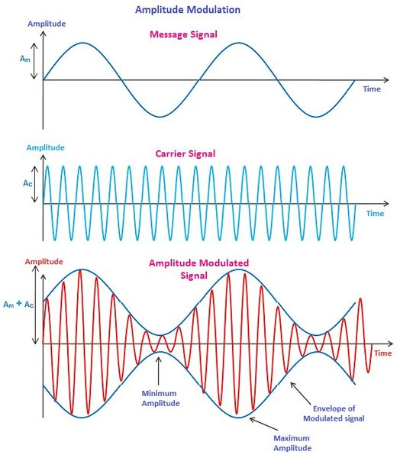

**Importance of Amplitude modulation:**

1. **Broadcasting:** AM is widely used in broadcasting radio signals. AM allows for the efficient transmission of audio signals over long distances, making it suitable for AM radio broadcasting. AM signals can propagate through the atmosphere and around obstacles, enabling wider coverage compared to other modulation techniques.
2. **Compatibility:** AM signals can be received by a wide range of receivers, including inexpensive and portable AM radios that are prevalent in many parts of the world. This compatibility makes AM an accessible and widely adopted modulation technique.
3. **Signal Intelligibility:** AM signals are relatively easy to demodulate, making them suitable for audio communication applications. The simplicity of AM receivers allows for clear reception of audio signals, making it suitable for voice transmission and music broadcasts.
4. **Resilience to Noise:** AM signals have a better noise immunity compared to other modulation techniques, such as frequency modulation (FM). The amplitude variations in an AM signal can be more easily recovered, even in the presence of noise or interference. This robustness is particularly beneficial for long-range communications and AM broadcasting.

**Uses of Amplitude Modulation:**

**Amateur Radio and Ham Radio:** Amateur radio operators often engage in building their own radio equipment as a hobby. Designing and implementing an AM transmitter and receiver using an LC oscillator and an envelope detector can be an exciting project for amateur radio enthusiasts, allowing them to communicate over short distances using AM modulation.

**Educational Purposes:** This project can serve as a practical learning experience for students studying electrical engineering, telecommunications, or related fields. It provides hands-on training in analog modulation and demodulation techniques, RF circuit design, and practical understanding of communication systems.

**Communication in Remote Areas:** In regions with limited access to telecommunications infrastructure, the implementation of AM transmitters and receivers can provide a simple and cost-effective means of establishing communication links over short distances. This can be particularly useful in remote areas, disaster-stricken regions, or during emergency situations.

**Vintage Radio Reproduction:** Enthusiasts of vintage electronics and radio technology can utilize this project to reproduce the experience of early radio receivers and transmitters. By understanding and replicating the workings of AM systems, they can enjoy the nostalgic feel of classic broadcasting and explore the history of radio communication.

**Brief explanation about Amplitude Modulation:**

**Modulating signal or message signal:**

the modulating signal refers to the original audio signal that carries the desired information. It is the signal that is used to modulate the amplitude of the carrier wave, resulting in the transmission of the audio signal over radio frequencies.

The modulating signal can be any audio waveform, such as speech, music, or any other sound. It represents the information or content that needs to be transmitted to the receiver. The modulating signal can be analog or digital, but in the context of AM, it is typically an analog audio signal.

The modulating signal is responsible for varying the amplitude of the carrier wave in proportion to the instantaneous amplitude of the audio signal. This modulation process encodes the audio information onto the carrier wave, allowing it to be transmitted and subsequently recovered at the receiver end.

**Carrier signal:**

the carrier signal refers to the high-frequency waveform that is modulated by the modulating signal to carry the information being transmitted. The carrier signal acts as a "carrier" for the modulating signal, allowing it to be transmitted over radio frequencies.

The carrier signal is typically a pure sine wave generated by an oscillator circuit. Its frequency is much higher than the frequencies present in the modulating signal, typically within the AM broadcast band (e.g., 550 to 1600 kHz). The carrier wave has a constant amplitude and frequency throughout the transmission.

During the modulation process, the carrier signal's amplitude is varied in accordance with the instantaneous amplitude of the modulating signal. This variation in amplitude encodes the information from the modulating signal onto the carrier signal.

The carrier signal is essential for the transmission of the modulating signal. It provides a stable and well-defined reference waveform that can be easily demodulated at the receiving end to extract the original modulating signal.

At the receiver, the demodulation process separates the modulating signal from the carrier signal, allowing the original audio signal to be recovered for playback or further processing.

In summary, the carrier signal in AM is a high-frequency sine wave that serves as a carrier for the modulating signal. It carries the information being transmitted and undergoes amplitude modulation to encode the modulating signal.

**Modulation index:**

The modulation index, also known as the modulation depth or modulation factor, is a parameter used to quantify the extent of modulation in an AM (Amplitude Modulation) signal. It indicates how much the amplitude of the carrier signal is varied in response to the modulating signal **modulation index value varies between 0 to 1.**

**Perfect modulation:**

Perfect modulation in the context of AM (Amplitude Modulation) refers to achieving the ideal balance between fidelity and efficiency in modulating the carrier signal. It involves ensuring that the modulation index is precisely controlled to achieve optimal signal quality and transmission efficiency.

In perfect modulation, the modulation index is set to an appropriate value within the recommended range **(typically around 1.0).** This ensures that the carrier signal's amplitude is varied enough to faithfully reproduce the modulating signal without exceeding the limits of overmodulation.

When modulation is perfect, the demodulated signal at the receiver faithfully represents the original modulating signal, providing high audio fidelity and intelligibility.

**Under modulation:**

In under modulation, the modulation index is typically less than 1.0, resulting in a lower level of amplitude variation in the carrier signal compared to the original modulating signal. But mostly we use the value 0.5 for under modulation.

**Poor modulation:**

Poor modulation in AM (Amplitude Modulation) refers to a condition where the modulation of the carrier signal by the modulating signal is not performed effectively or accurately. It indicates a suboptimal or faulty modulation process that can result in degraded signal quality and compromised audio fidelity.

**Poor modulation in AM (Amplitude Modulation) refers to a condition:**

where the modulation of the carrier signal by the modulating signal is not performed effectively or accurately. It indicates a suboptimal or faulty modulation process that can result in degraded signal quality and compromised audio fidelity.

Several factors can contribute to poor modulation in AM:

1. Insufficient Modulation Depth: Poor modulation can result from a low modulation index, where the amplitude variation of the carrier signal is insufficient to faithfully represent the modulating signal. This leads to a loss of audio fidelity and reduced signal quality.
2. Overmodulation: Poor modulation can also occur when the modulation index exceeds 1.0, resulting in overmodulation. In this case, the carrier signal's amplitude is excessively varied, leading to distortion and the introduction of unwanted harmonics in the transmitted signal.

**Modulated signal:**

The modulated signal in AM can be visualized as a waveform in the time domain or a spectrum in the frequency domain. In the time domain, the modulated signal consists of oscillations with varying amplitudes, corresponding to the variations in the message signal. In the frequency domain, the modulated signal's spectrum shows the carrier signal's frequency along with the sidebands containing the message signal's information.

To transmit and receive AM signals accurately, it is crucial to consider factors such as carrier frequency, modulation index (which determines the extent of amplitude variation), and bandwidth requirements. Additionally, noise and interference present in the communication channel can affect the quality of the modulated signal and the demodulation process.

In summary, the modulated signal in amplitude modulation is created by varying the amplitude of a carrier signal in proportion to the message signal's amplitude. It consists of the carrier signal, the upper sideband, and the lower sideband, which carry the information. The modulated signal is then demodulated at the receiver to recover the original message signal.

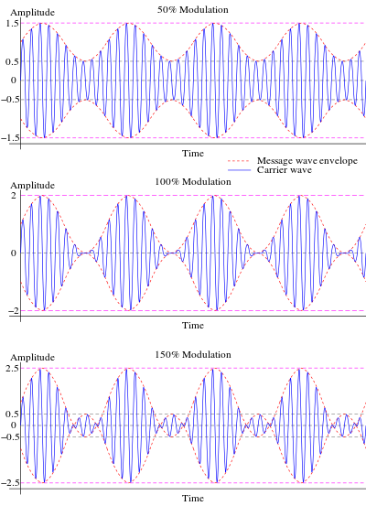

1. **Discuss the problems in the simulation and modelling of the Selected Topic and /or**

**Application**

Amplitude modulation (AM) is a widely used technique in analog communication systems, but it is not without its challenges in simulation and modeling. Here are some problems that can arise when simulating and modeling AM:

Bandwidth considerations: AM signals occupy a relatively wide bandwidth compared to other modulation techniques. Accurately simulating and modeling the bandwidth requirements of AM signals is crucial to understand factors such as channel capacity, interference, and the effects of filtering. Incorporating realistic bandwidth limitations into simulations and models can be challenging, particularly when dealing with complex signal scenarios or nonlinear systems.

Noise and interference: In real-world communication systems, noise and interference are inevitable. Accurately incorporating the effects of noise and interference into AM simulations and models is important to assess the system's performance and determine the required signal-to-noise ratio (SNR) for reliable communication. However, accounting for noise and interference accurately in simulations can be complex, as it involves modeling various noise sources, channel impairments, and interference sources.

Carrier and message signal synchronization:

In AM, the accurate recovery of the message signal at the receiver relies on proper synchronization between the carrier and message signal. Any deviation or error in the synchronization process can degrade the quality of the demodulated signal. Simulating and modeling the synchronization process requires careful consideration of factors such as carrier frequency offset, phase noise, and timing jitter, which can impact the performance of the demodulation process.

Non-ideal components:

Real-world AM systems employ various electronic components such as amplifiers, filters, and mixers, which can introduce imperfections and non-idealities. These non-idealities, including frequency response deviations, phase distortions, and nonlinear behavior, can significantly affect the performance of an AM system. Simulating and modeling these non-ideal components accurately is crucial to understand their impact on the overall system performance.

Modeling fading and multipath propagation: In wireless communication scenarios, AM signals can experience fading and multipath propagation effects due to factors like signal reflections, diffraction, and scattering. These effects introduce time-varying amplitude variations and phase shifts in the received signal. Incorporating accurate models for fading and multipath propagation into AM simulations is essential to assess the system's performance in realistic wireless environments.

Addressing these problems requires a combination of theoretical understanding, advanced modeling techniques, and careful validation against real-world measurements. It is important to consider the specific requirements of the system being simulated or modeled and make appropriate simplifications or assumptions without compromising the accuracy and relevance of the results.

1. **The best models which provide better results in the evaluation**

In amplitude modulation (AM), there are several models that have been developed over the years to improve the quality and efficiency of the modulation process. Here are a few notable models that have been widely recognized for providing better results in amplitude modulation:

1. Double-Sideband Suppressed Carrier (DSB-SC) Modulation: The DSB-SC modulation model is a simple and efficient technique that removes the carrier signal from the modulated output. By eliminating the carrier, it allows for more efficient use of power and bandwidth. DSB-SC modulation is commonly used in applications where the carrier signal is not required for demodulation, such as in radio broadcasting.
2. Pulse Amplitude Modulation (PAM): PAM is a digital modulation technique that converts a digital signal into a series of discrete amplitude levels. It is commonly used in digital communication systems, such as fiber-optic transmission and Ethernet, to transmit digital data over analog channels. PAM provides efficient and reliable data transmission by encoding digital information into different amplitude levels.
3. Single Sideband (SSB) Modulation: SSB modulation is a technique that eliminates one of the sidebands and the carrier signal, transmitting only a single sideband. This results in improved spectral efficiency compared to full AM modulation. SSB modulation is utilized in long-distance radio communications and amateur radio applications, where efficient use of bandwidth is crucial.
4. Quadrature Amplitude Modulation (QAM): QAM is a modulation technique that combines both amplitude and phase modulation. It allows for the transmission of multiple bits per symbol, making it highly efficient in terms of data transmission. QAM is widely used in digital communication systems, such as cable modems and wireless networks, where high data rates and spectral efficiency are required.
5. Vestigial Sideband (VSB) Modulation: VSB modulation is a technique that allows for the transmission of a reduced bandwidth signal while maintaining the integrity of the modulated signal. It achieves this by partially suppressing one sideband and transmitting a vestige of the other sideband. VSB modulation is commonly used in television broadcasting, particularly in digital television (DTV) systems, to optimize bandwidth utilization and improve signal quality.
6. **Description of the solution and any relevant theory**

Amplitude modulation (AM) is a modulation technique used to transmit information by varying the amplitude of a carrier signal in accordance with the modulating signal. The modulating signal typically carries the desired audio or data information.

Relevant Theory:

The theory of amplitude modulation is based on the concept of superposition, where the modulating signal is combined with the carrier signal to produce the modulated waveform. The mathematical representation of AM involves multiplying the carrier signal by the instantaneous amplitude variations of the modulating signal.

The modulated waveform can be expressed as:

s(t) = (1 + ka * m(t)) * Ac * cos (2πfc * t)

Where:

• s(t) represents the modulated signal

• ka represents the modulation index, which determines the extent of amplitude variation

• m(t) is the modulating signal

• Ac represents the amplitude of the carrier signal

• fc is the frequency of the carrier signal

• t denotes time

The modulation index (ka) determines the level of modulation and is calculated as the ratio of the peak amplitude of the modulating signal to the amplitude of the carrier signal. It influences the sideband spectrum and overall bandwidth of the modulated signal.

The demodulation process involves extracting the modulating signal from the modulated waveform. Different demodulation techniques, such as envelope detection or coherent demodulation, can be employed based on the specific modulation scheme and requirements of the system.

The theory of amplitude modulation forms the foundation for understanding and implementing AM systems across various applications, including radio broadcasting, telecommunications, and audio transmission. It provides the basis for signal analysis, system design, and optimization in the field of modulation and demodulation.

1. **Theoretical and Technical Understanding & Discussion with Simulation Results**

**Transmitter signal:**

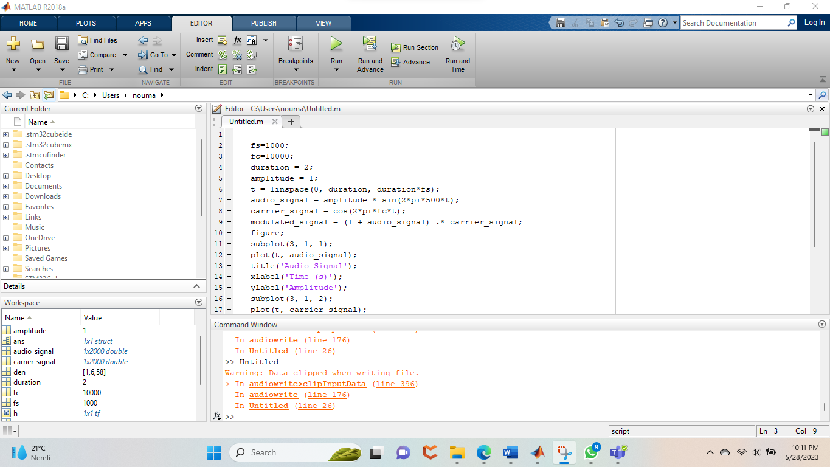

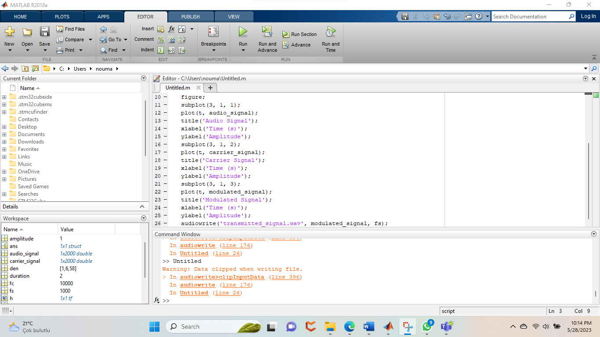

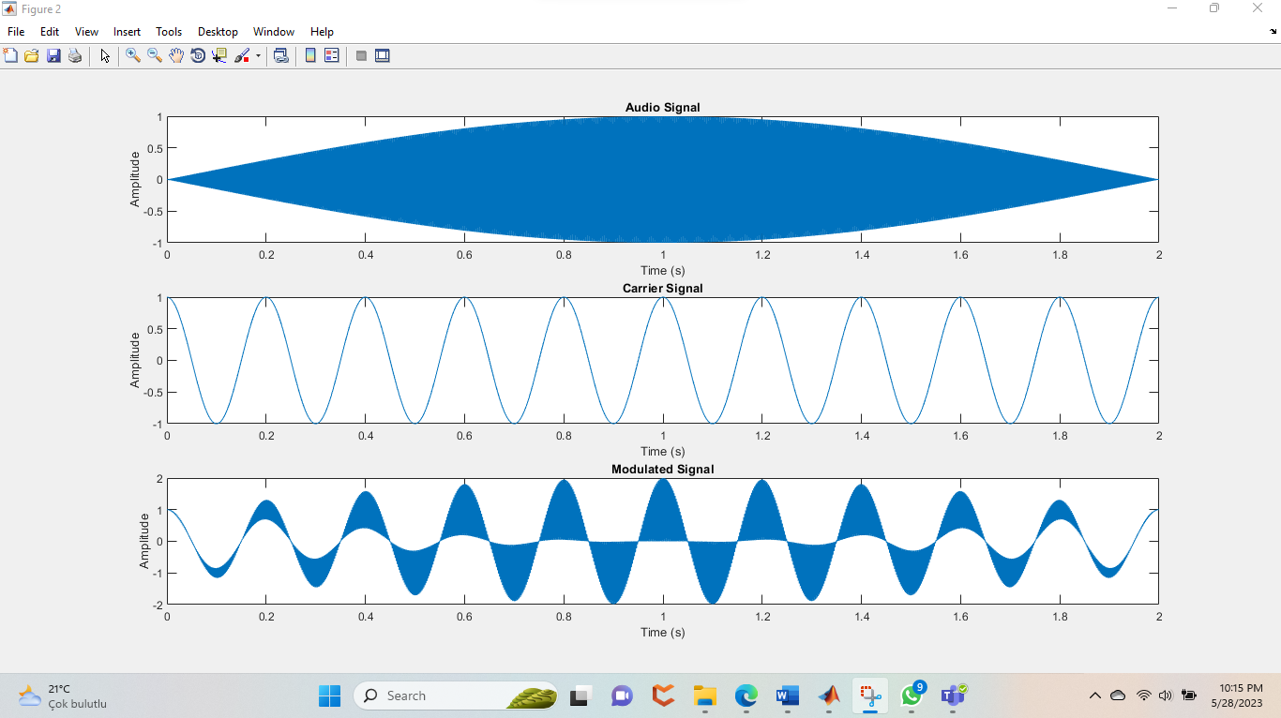

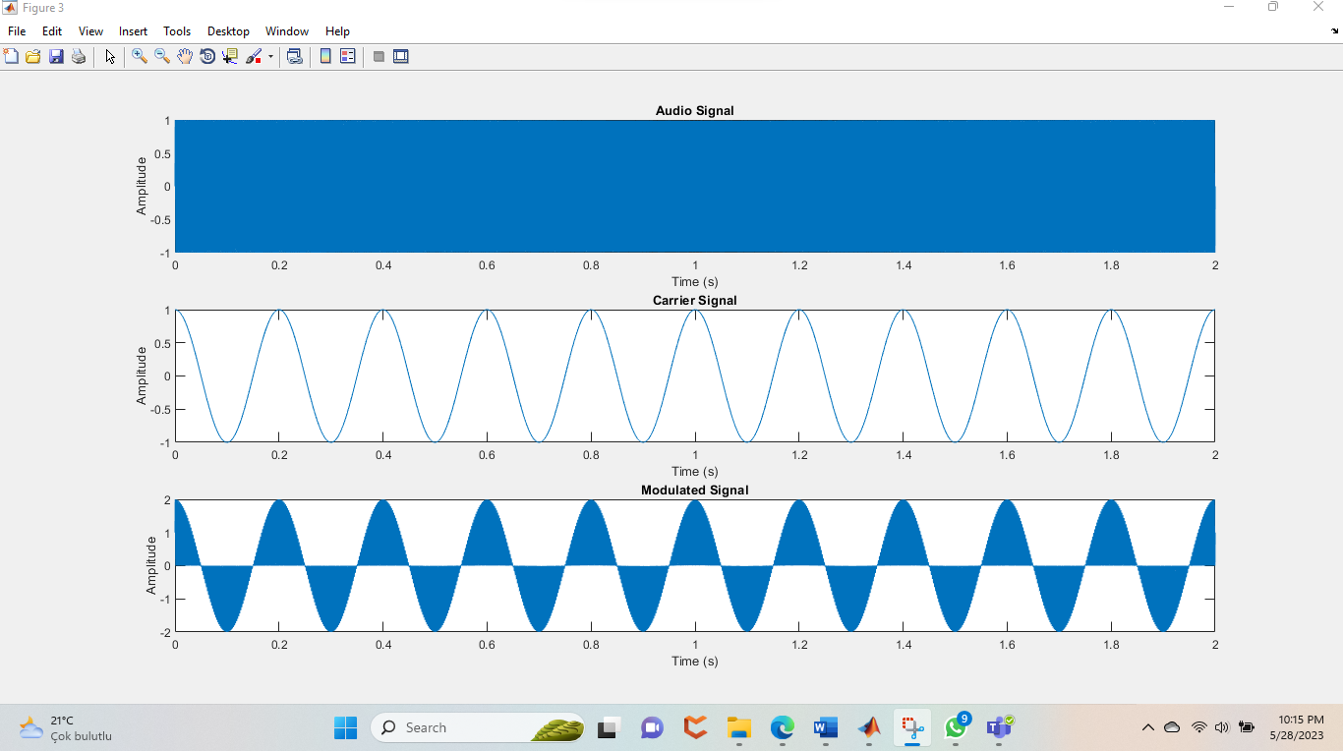

**Receiver signal:**

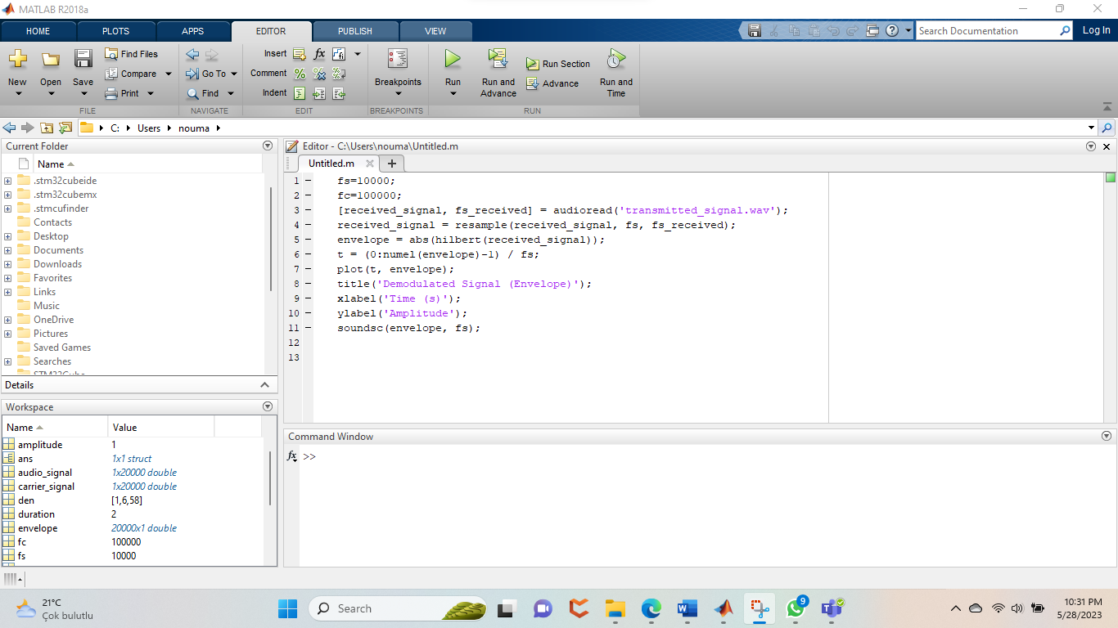

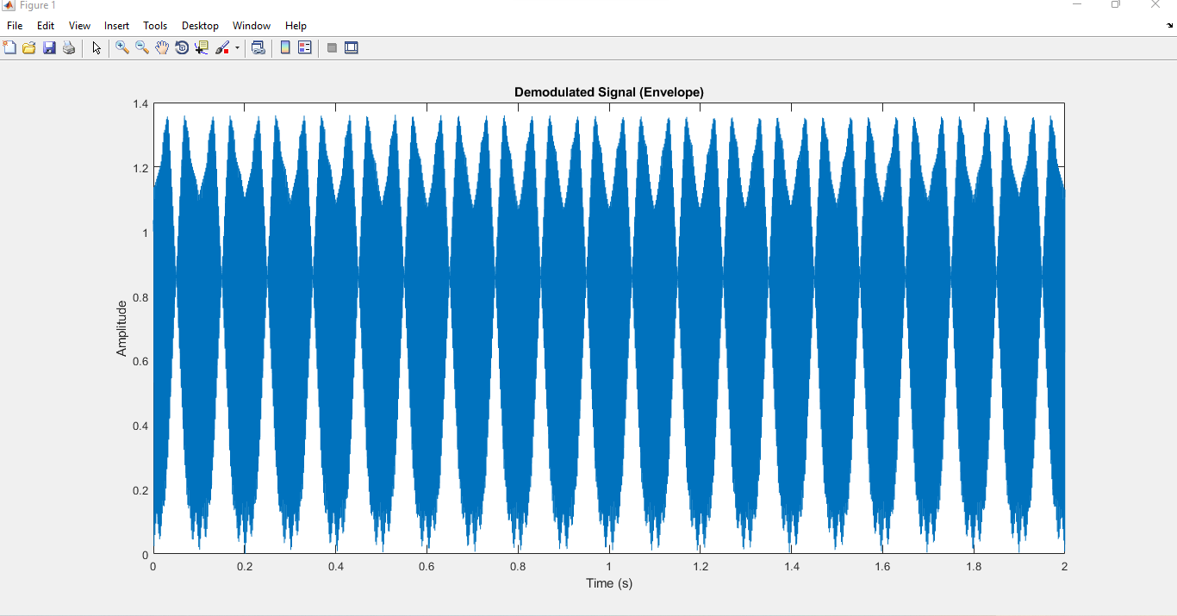

Message signal frequency:400

Carrier signal frequency:4000

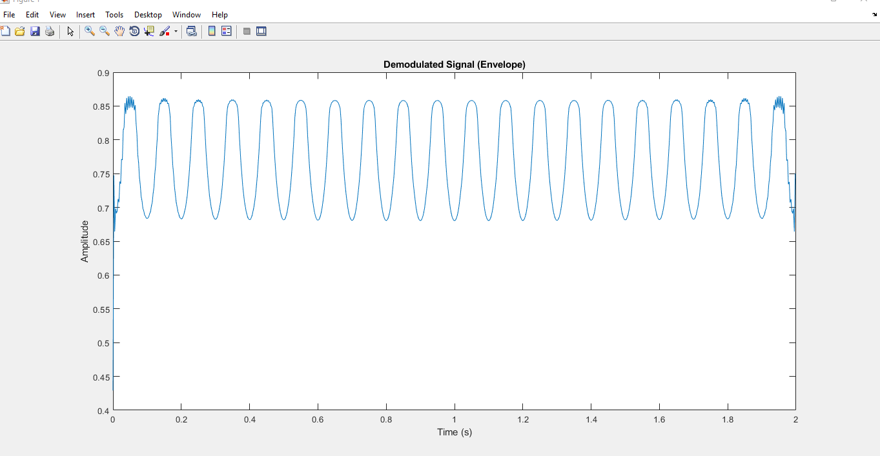

**Amplitude modulation by proteus:**

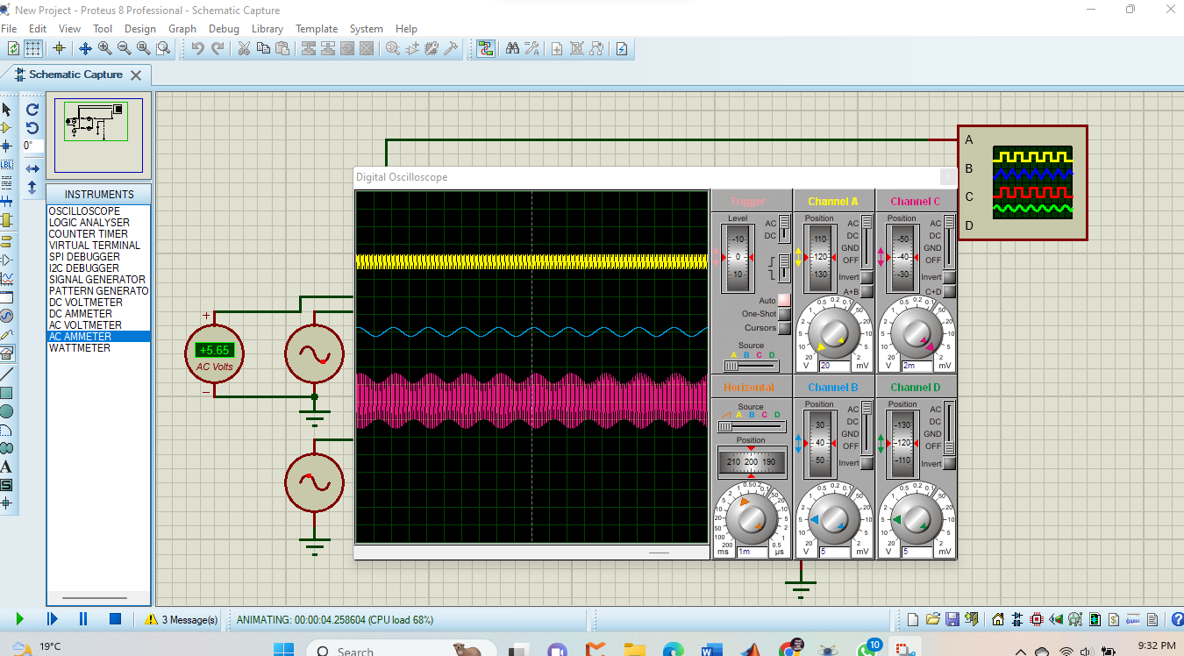

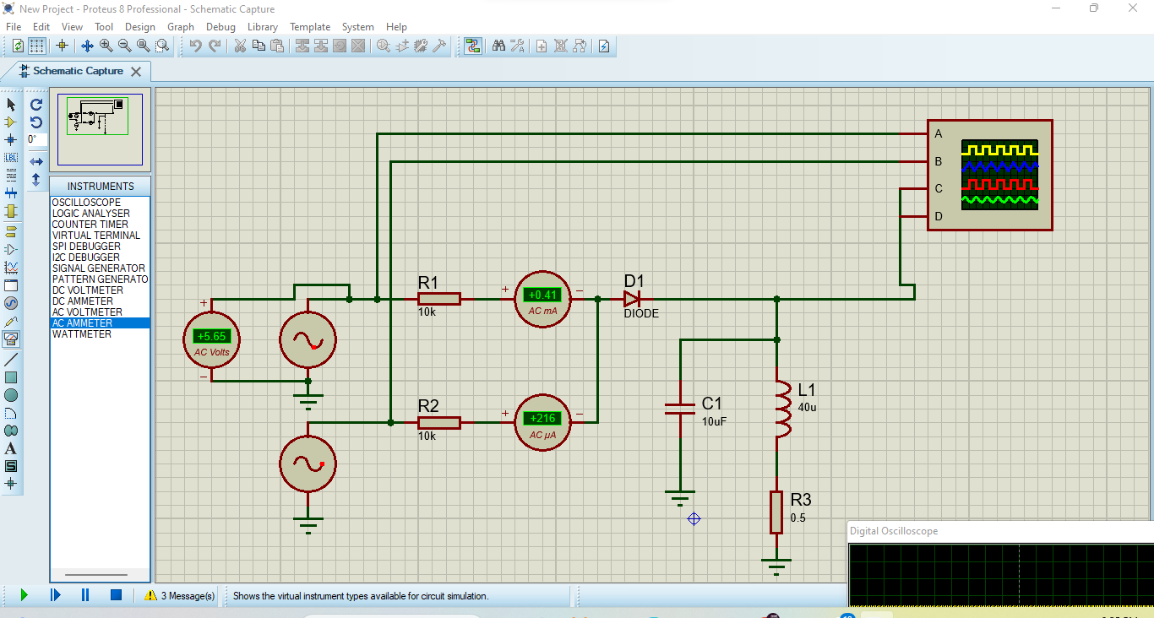

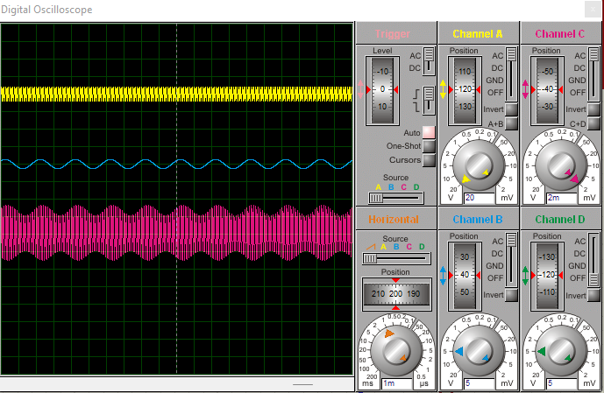

**Theoretical calculations:**

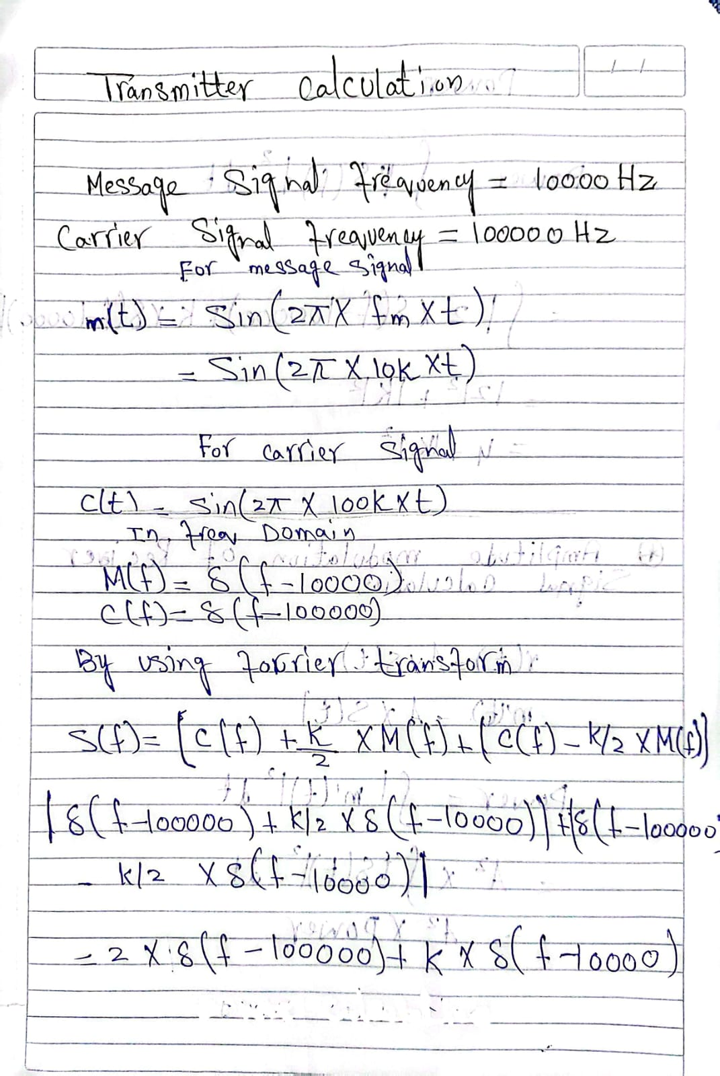

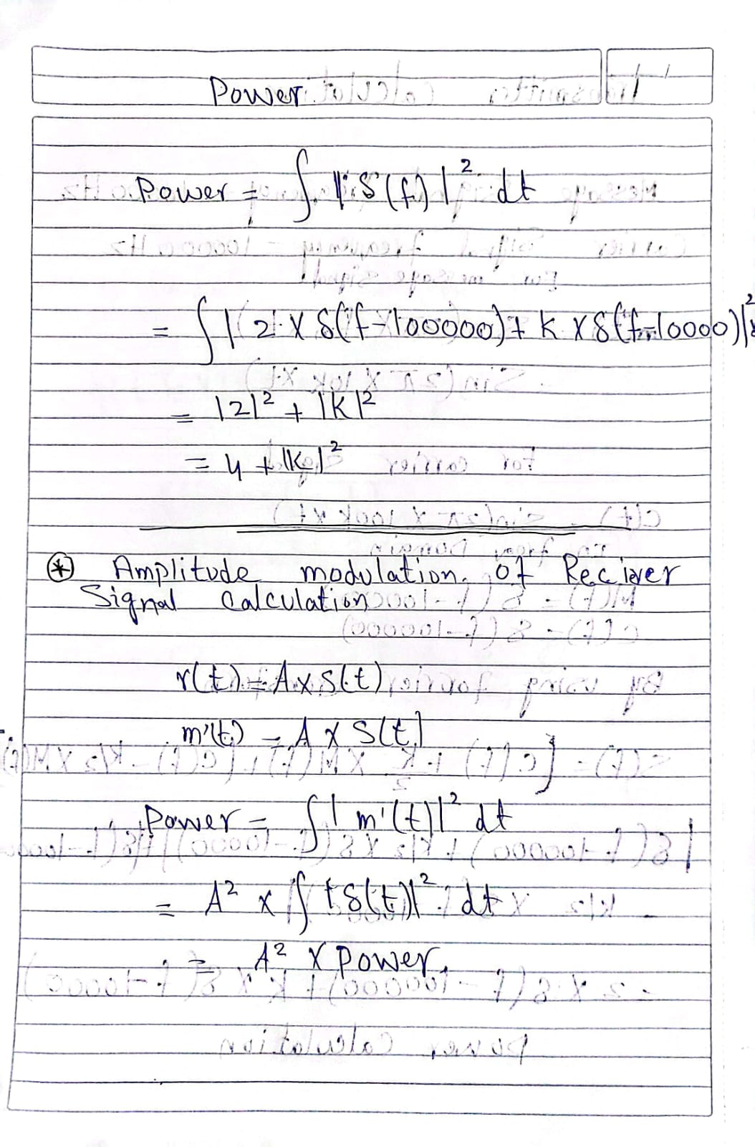

1. **Conclusion:**

In conclusion, amplitude modulation (AM) is a modulation technique that enables the transmission of information by varying the amplitude of a carrier signal. It has been widely used in various applications, including radio broadcasting, telecommunications, and audio transmission. AM allows for the efficient transmission of analog and digital signals, providing a means to convey audio, data, and other forms of information.

AM offers several advantages, such as simplicity of implementation, compatibility with existing receiver technologies, and resilience to noise. It has played a crucial role in the development of communication systems, particularly in early radio broadcasting. AM also provides a relatively wide bandwidth, allowing for the transmission of multiple signals simultaneously.

However, AM is not without its limitations. It is sensitive to noise and interference, which can degrade the signal quality. The use of AM also requires a larger bandwidth compared to other modulation techniques, limiting the number of channels that can be accommodated within a given frequency range. Additionally, AM is susceptible to non-linear distortion and limitations imposed by the frequency response of the system.

Despite its drawbacks, AM continues to be employed in various applications where its simplicity and compatibility outweigh the challenges associated with it. Moreover, advancements in signal processing techniques and modulation schemes have led to improved performance and overcome some of the limitations of traditional AM.

In summary, amplitude modulation has played a significant role in the history of communication systems and remains relevant today. Its ability to transmit information through amplitude variations of a carrier signal has paved the way for advancements in broadcasting, telecommunications, and audio transmission. While facing challenges, AM continues to be a fundamental modulation technique, and its principles form the basis for further developments in modulation and demodulation technologies.

1. **References:**

➢ Carlson, A. B., & Crilly, P. B. (2001). Communication Systems: An Introduction to Signals and Noise in Electrical Communication (4th Edition). McGraw-Hill Education.

➢ Couch, L. W. (2013). Digital and Analog Communication Systems (8th Edition). Pearson.

➢ Gibson, J. D. (2004). Principles of Digital and Analog Communications (2nd Edition). Prentice Hall.

➢ Stern, R. A., & Mahmoud, S. A. (2004). Communication Systems: Analysis and Design. Pearson Prentice Hall.

➢ Wakerly, J. F. (2010). Digital Design Principles and Practices. Prentice Hall.

✓ Sabin, W. (2006). Amplitude modulation: Fundamentals. IEEE Communications Magazine, 44(9), 34-39.

✓ Ziemer, R. E., & Tranter, W. H. (2016). Principles of communications systems modulation and noise. John Wiley & Sons.

✓ Kennedy, G., & Davis, B. (2010). Electronic communication systems. Tata McGraw-Hill Education.